ANACONDA FOR PYTHON INSTALLATION GUIDE

Anaconda is a free, easy-to-install package manager, environment manager, and Python distribution with a collection of 1,500+ open source packages with free community support. Anaconda is platform-agnostic, so you can use it whether you are on Windows, macOS, or Linux.

This document walks you through the steps required to Install Anaconda on Mac, Windows and Linux operating systems using Graphical and Command line Interface on a step by step basis. It is recommended to install the latest Version of Python (i.e. Python 3.x) as opposed to the Python 2.x as the old version is no longer supported by its creators, the Python Software Foundation

Operating System:
Please use the hyperlinks below to traverse through the document

For Mac OS Graphical Install click here and for command line installation click here
For Windows OS Graphical Install click here
For Linux OS click here

Installing on macOS:

macOS graphical install

- Download the graphical macOS installer for your version of Python.
- Double-click the downloaded file and click continue to start the installation.
- Answer the prompts on the Introduction, Read Me, and License screens.
- Click the Install button to install Anaconda in your ~/opt directory (recommended)
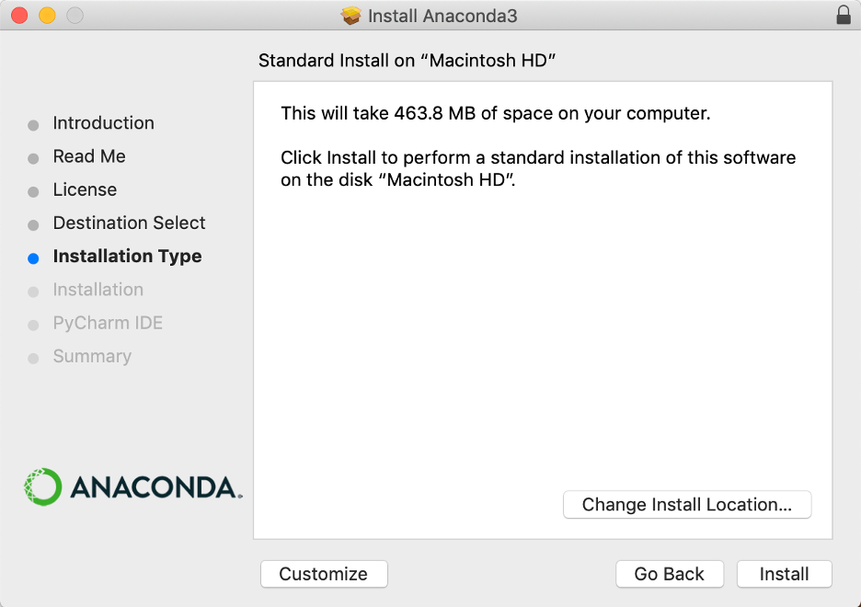

- OR, click the Change Install Location button to install in another location (not recommended).
On the Destination Select screen, select Install for me only.
Note
If you get the error message “You cannot install Anaconda in this location,” reselect Install for me only.

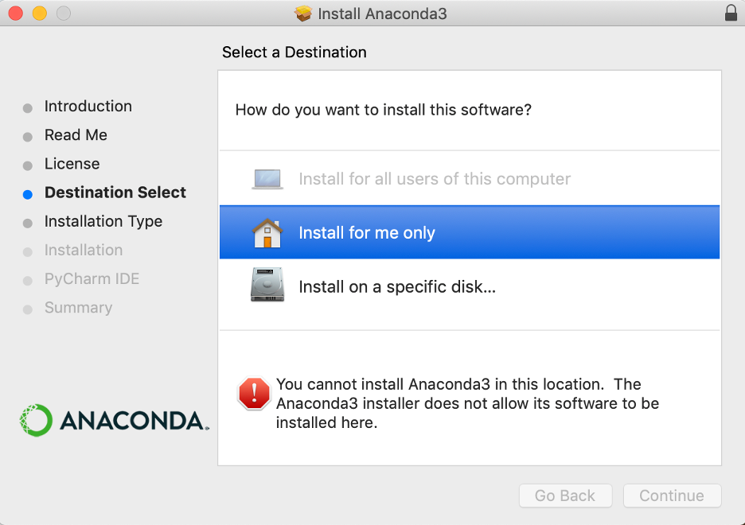

- Click the continue button.
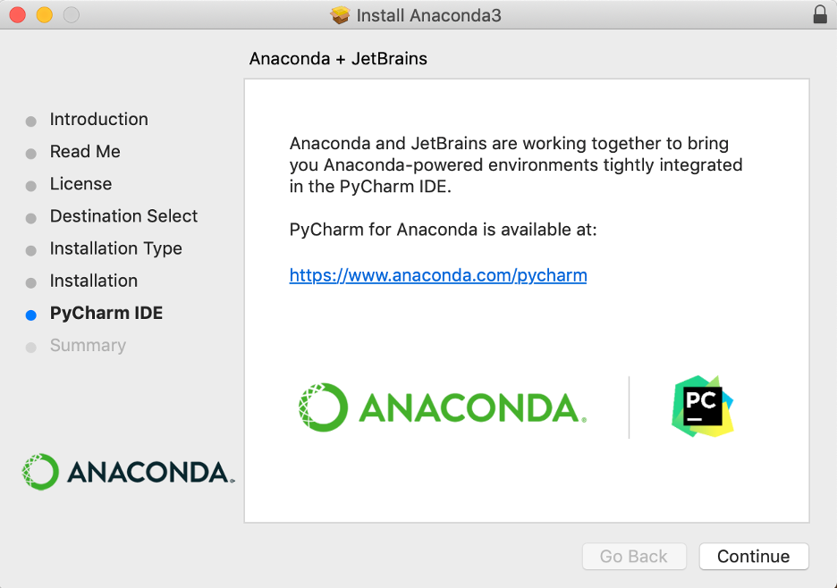

Or to install Anaconda without PyCharm, click the Continue button.
- A successful installation displays the following screen
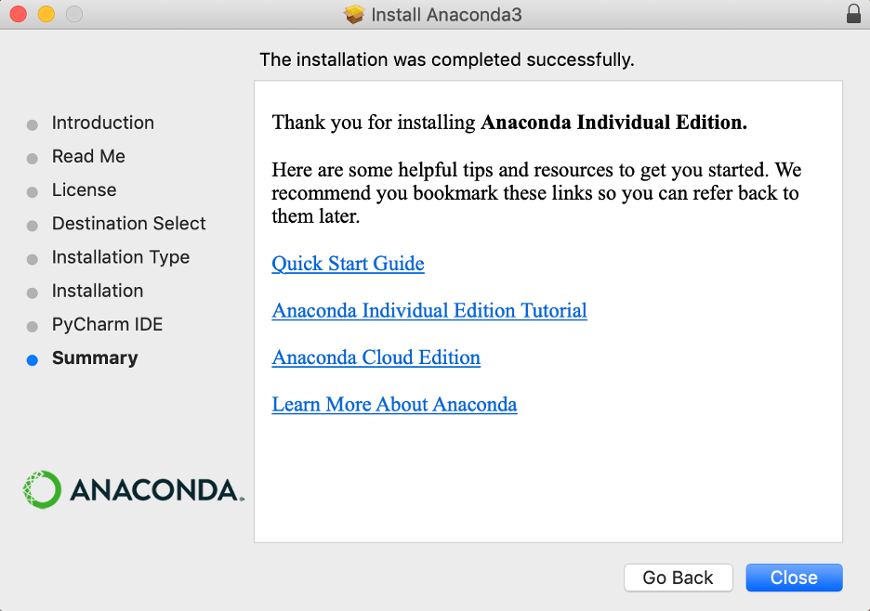

Using the command-line install

Use this method if you prefer to use a terminal window.

- In your browser, download the command-line version of the macOS installer for your system.
  - Open a terminal and run the following:
shasum -a 256 /path/filename
Note
Replace /path/filename with your installation’s path and filename.
- Install for Python 3.7 or 2.7:
  - For Python 3.7 enter the following:
bash ~/Downloads/Anaconda3-2020.02-MacOSX-x86_64.sh
  - For Python 2.7, open the Terminal.app or iTerm2 terminal application and then enter the following:
bash ~/Downloads/Anaconda2-2019.10-MacOSX-x86_64.sh
Note
Include the bash command regardless of whether or not you are using the Bash shell.
Note
Replace ~/Downloads with your actual path and Anaconda3-2020.02-MacOSX-x86_64.sh with actual name of the file you downloaded.
- The installer prompts “In order to continue the installation process, please review the license agreement.” Click Enter to view the license terms.
- Scroll to the bottom of the license terms and enter yes to agree to them.
- The installer prompts you to Press Enter to confirm the location, Press CTRL-C to cancel the installation or specify an alternate installation directory. If you confirm the default location, it will display PREFIX=/home/<user>/anaconda<2 or 3> and continue the installation.
Note
Unlike the graphical install, installing the shell file will place it in ~/anaconda<2 or 3> by default, not ~/opt. This is due to limitations with installing .pkg files on macOS Catalina.
Installation may take a few minutes to complete.
Note
We recommend you accept the default install location. Do not choose the path as /usr for the Anaconda/Miniconda installation.
- The installer prompts “Do you wish the installer to initialize Anaconda3 by running conda init?” We recommend “yes”.
Note
If you enter “no”, then conda will not modify your shell scripts at all. In order to initialize after the installation process is done, first run source<path to conda>/bin/activate and then run conda init.
Note
If you are on macOS Catalina, the new default shell is zsh. You will instead need to run source <path to conda>/bin/activate followed by conda init zsh.
- The installer displays “Thank you for installing Anaconda!”
- Optional: The installer describes the partnership between Anaconda and JetBrains and provides a link to install PyCharm for Anaconda athttps://www.anaconda.com/pycharm.
- Close and open your terminal window for the Anaconda installation to take effect.
- To control whether or not each shell session has the base environment activated or not, run conda config --set auto_activate_base False orTrue. To run conda from anywhere without having the base environment activated by default, use conda config --set auto_activate_baseFalse. This only works if you have run conda init first.
Note
conda init is available in conda versions 4.6.12 and later.

Installing on Windows OS:

- Download the Anaconda installer.
- Double click the installer to launch.
Note
To prevent permission errors, do not launch the installer from the Favorites folder.
Note
If you encounter issues during installation, temporarily disable your anti-virus software during install, then re-enable it after the installation concludes. If you installed for all users, uninstall Anaconda and re-install it for your user only and try again.
- Click Next.
- Read the licensing terms and click “I Agree”.
- Select an install for “Just Me” unless you’re installing for all users (which requires Windows Administrator privileges) and click Next.
- Select a destination folder to install Anaconda and click the Next button.
Note
Install Anaconda to a directory path that does not contain spaces or unicode characters.
Note
Do not install as Administrator unless admin privileges are required.

- Choose whether to add Anaconda to your PATH environment variable. We recommend not adding Anaconda to the PATH environment variable, since this can interfere with other software. Instead, use Anaconda software by opening Anaconda Navigator or the Anaconda Prompt from the Start Menu.
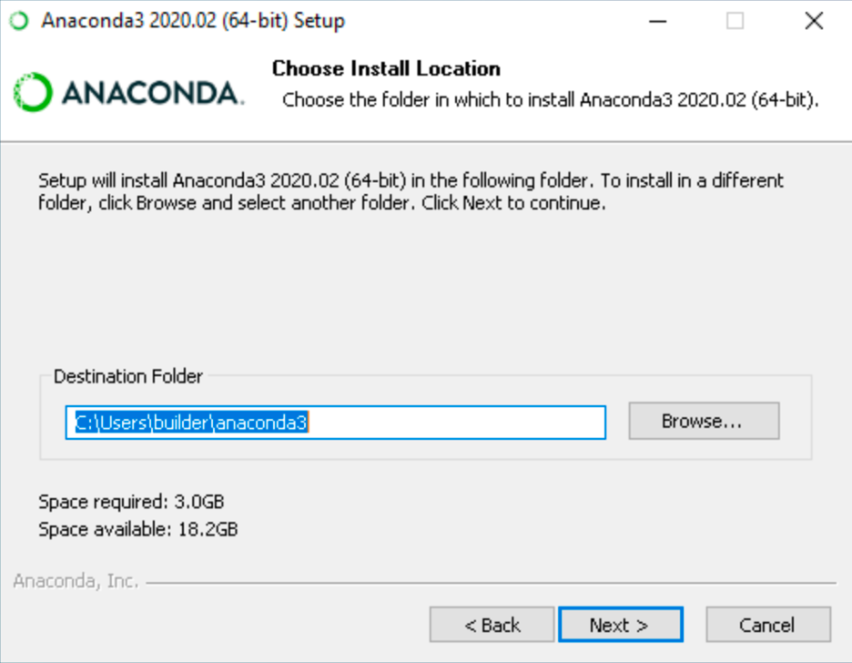

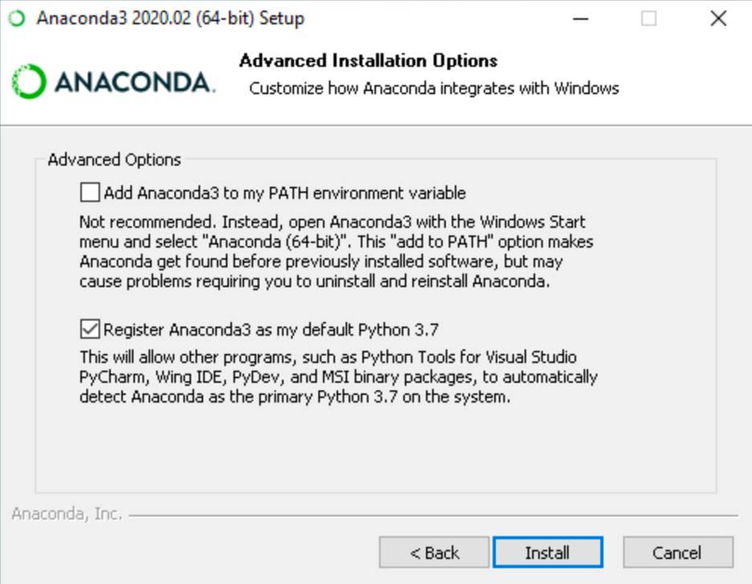

- Choose whether to register Anaconda as your default Python. Unless you plan on installing and running multiple versions of Anaconda or multiple versions of Python, accept the default and leave this box checked.
- Click the Install button. If you want to watch the packages Anaconda is installing, click Show Details.
- Click the Next button.

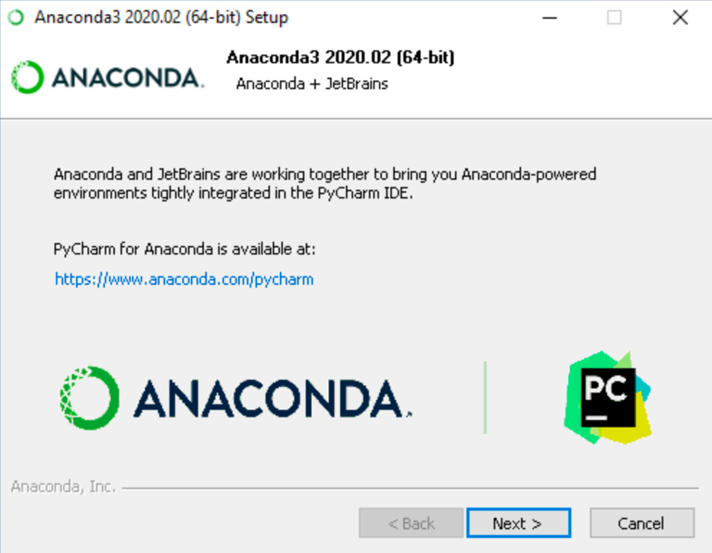

Or to install Anaconda without PyCharm, click the Next button

- After a successful installation you will see the “Thanks for installing Anaconda” dialog box
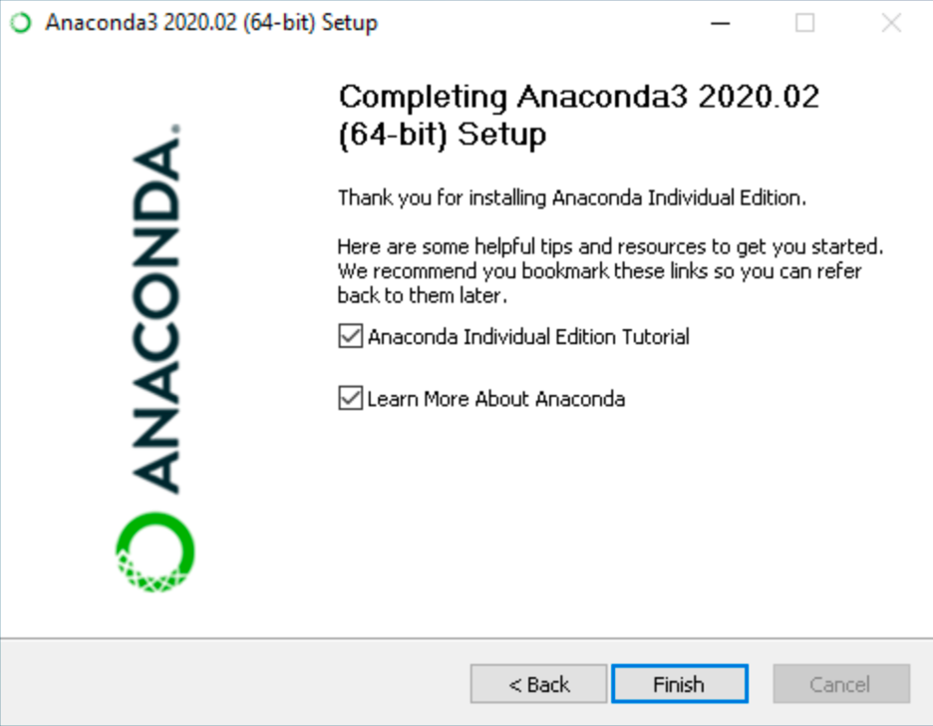

- Click the Finish button.

Linux OS Installation

For x86 systems.
- In your browser, download the Anaconda installer for Linux.

- Open a terminal and run the following:
sha256sum /path/filename
- Enter the following to install Anaconda for Python 3.7:
bash ~/Downloads/Anaconda3-2020.02-Linux-x86_64.sh
OR Enter the following to install Anaconda for Python 2.7:
bash ~/Downloads/Anaconda2-2019.10-Linux-x86_64.sh
Note
Include the bash command regardless of whether or not you are using Bash shell.
Note
If you did not download to your Downloads directory, replace ~/Downloads/ with the path to the file you downloaded.
- The installer prompts “In order to continue the installation process, please review the license agreement.” Click Enter to view license terms.
- Scroll to the bottom of the license terms and enter “Yes” to agree.
- The installer prompts you to click Enter to accept the default install location, CTRL-C to cancel the installation, or specify an alternate installation directory. If you accept the default install location, the installer displays “PREFIX=/home/<user>/anaconda<2 or 3>” and continues the installation. It may take a few minutes to complete.
Note
We recommend you accept the default install location. Do not choose the path as /usr for the Anaconda/Miniconda installation.
- The installer prompts “Do you wish the installer to initialize Anaconda3 by running conda init?” We recommend “yes”.
Note
If you enter “no”, then conda will not modify your shell scripts at all. In order to initialize after the installation process is done, first run source<path to conda>/bin/activate and then run conda init. See FAQ.
- The installer finishes and displays “Thank you for installing Anaconda<2 or 3>!”
- The installer provides a link to install PyCharm for Anaconda at https://www.anaconda.com/pycharm.
- Close and open your terminal window for the installation to take effect, or you can enter the command source ~/.bashrc.
- To control whether or not each shell session has the base environment activated or not, run conda config --set auto_activate_base False orTrue. To run conda from anywhere without having the base environment activated by default, use conda config --set auto_activate_baseFalse. This only works if you have run conda init first.

Note
conda init is available in conda versions 4.6.12 and later.

